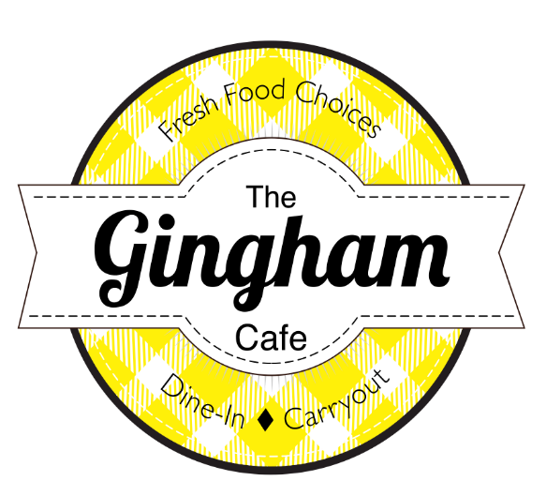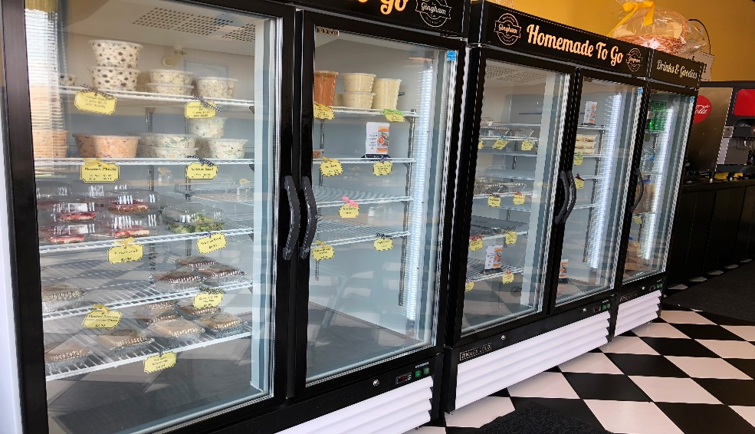

Beginning February 3rd
We will stay open on Wednesday’s until 6pm for this special offer for CMCSS Employees!

Feed a family of 4 for $55.00
Choose your entrée, two sides, bread and dessert

Orders must be placed by 3pm on the Monday before. You can email orders to angela@ginghamcafe.com, text your order to (931) 572-4141 or even call the café at
(931) 919-4986
Come inside to pick up your order or call when you get here, and we will bring it to you. We can take your payment from your car!

Entrée Choices:
Pick any two entrees or both the same. Each entrée is two servings
- Almond Chicken and Wild Rice
- Spaghetti Bake
- Turkey Tetrazzini
- Spinach Lasagna
- Chicken & Asparagus Fettuccine

Side Choices:
Pick any two sides. One side has four servings.
- Spinach Casserole
- Mashed Potatoes with Gouda Cheese
- Gingham Green Beans
- Mac n Cheese
- Red Potato Salad with Dill
- Broccoli Salad
- Pretzel Salad
- Grape Salad
- Tradition Salad with dressing choice
Ranch, Poppyseed, Balsamic

Bread Choices:
Pick one – 4 pieces per order
- Yeast Rolls
- Mexican Cornbread
- Banana Bread
- Lemon Blueberry Bread
- Zucchini Bread
- Funnel Cake Bread

Dessert Choices:
Pick one – 4 desserts per order
- Chocolate Chess Squares
- Gooey Toffee Bars
- Caramel Brookies

Add Ons:
- Gallon of Gingham Fruit Tea $12.75
- Gallon of Sweet or Unsweet Tea $7.65
- Loaf of Sweet Bread $7.90
- Quart of Creamy Potato or Tomato Basil Soup $14.90

