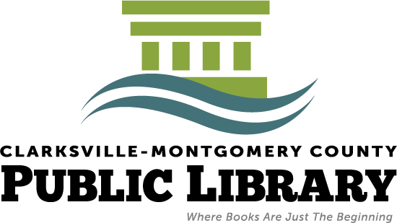

Permission form for ELECTRONIC ACCESS-ONLY library card at the Clarksville Montgomery County Public Library

Student name (Please print) _____________________________________________________________
Student address (Please print) ____________________________________________________________
_____________________________________________________________________________________
Pin number (Choose a personal identification number with 4 digits) ____________

I agree to allow my child to access all electronic materials available through the library’s website, including but not limited to: Freegal Music, Regional eBook & Audiobook Downloadable System (READS), Universal Class, Mango Languages, Tennessee Electronic Library, Fold3 (military database), and other databases.
I understand that the Clarksville-Montgomery County Public Library is not responsible for the exclusion of any adult-level content that may be viewed or heard during access of the electronic materials. It is the responsibility of parents or guardians to provide guidelines and guidance for access of these materials by their minor children.

Signed______________________________________________________ Legal parent/guardian of child
Date________________________
(Please note: If your child currently has a library card in good standing, access to all of the above materials are already available to him/her. If you would like to change the electronic access-only card to a library card with full borrowing privileges in the future, simply visit the library in person with the card and staff will walk you through additional steps to process the request.)

